

Novel Approach Towards Spam Classification

Indian Space Research Organisation and Jamia Millia Islamia, Smart India Hackathon - 2017

─

Team: INSIGHT-JMI

Department of Computer Engineering

Jamia Millia Islamia
New Delhi - 110025

Database

This project requires a very clear and concise description and classification of databases. We are using Top - down design method to design the database.
The four main parts of our database is
- Information about all the doctors in the hospital
- Information about the patients registering in the hospital
- A complete list of all the medicines (drugs + salts)available in the market to assist the doctor to write up the prescription
- Database of every single shop in the city
- This will be done with the help of GST generated receipt of every shop
- The medicines will be broken into two parts:
i.)Brand name ii.)Salts name
- One dataset will contain all the Brand names with their price
- The other will contain all the salts
- These two datasets will be a complete join to enable searching in both ways

Dataset Description

e-MedExpert Dataset

The e-MedExpert is a large database of drugs and medicines. It consists of both Generic and Brand name drugs.The dataset is available at http://www.emedexpert.com/lists/brand-generic.shtml

MyDawai Dataset

This dataset was one of the datasets for the data mining competition associated with ICONIP 2010. The dataset contains 4327 messages out of which there are 2949 non-spam messages (HAM) and 1378 spam messages (SPAM). The dataset is available for public use at http://csmining.org/index.php/spam-email-datasets-.html

GetDavai Dataset

The ling spam dataset contains 4 directories, each one of these 4 directories contains 10 subdirectories (part1 to part10). These correspond to the 10 partitions of the corpus that were used in the 10-fold experiments. In each repetition, one part was reserved for testing and the other 9 were used for training. Each one of the 10 subdirectories contains both spam and legitimate messages, one message in each file. Files whose names have the form spmsg*.txt are spam messages. All other files are legitimate messages. The dataset is attributed to Androutsopoulos, J. Koutsias, K.V. Chandrinos, George Paliouras, and C.D. Spyropoulos, "An Evaluation of Naive Bayesian Anti-Spam Filtering".
2

Technology Stack

Front – End
- HTML 5
- CSS
- BOOTSTRAP
- JAVASCRIPT
- VUE.JS
- SEMENTIC UI
- ANGULAR JS

Back-End
- NODE.JS
- EXPRESS
- NPM

Database
- MONGO DB

Map
- Google map API
- MapBox

Messaging Services
- M1
- M2

Goals

- To represent the data in a format where statistical learning tools can be applied.

- Passing the mathematically represented data through a statistical classifier.

- Doctor’s Interface
Below we discuss both the interface in some details with prototypes.

Description of Our Interface

Our Interface is the front-end of our project. This is the part which will be used by the hospital.
i.e. by the OPD to enter new registration of the patients and by the doctor to write up the application. The front-end interface is formally connected to the backend and all the information entered here goes to the back-end server.
There are two parts of our Interface:
- OPD Interface
- Doctor’s Interface
Below we discuss both the interface in some details with prototypes.

OPD Interface

OPD or Out Patient Department practically acts as a reception in the hospital. This is the interface that will appear on the receptionist’s computer. There he/she will fill out all the relevant details of the patient. This includes details like name, age, gender, address, etc.
The form will also generate a Patient ID which will later be used by the doctor to get information from the database. Once the submit button is pressed all the information goes into backend database. Also a SMS will be sent to patient’s mobile no. Indicating the doctor’s name who will attend him/her, room number in which to go and also the queue status. The prototype of the interface is shown below:
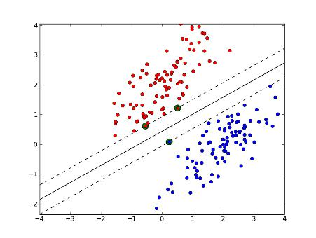

Doctor’s Interface

This is a digital prescription form that the doctor will get once the patient has reistered at the OPD. There are basically two parts to this form as shown in the figure.
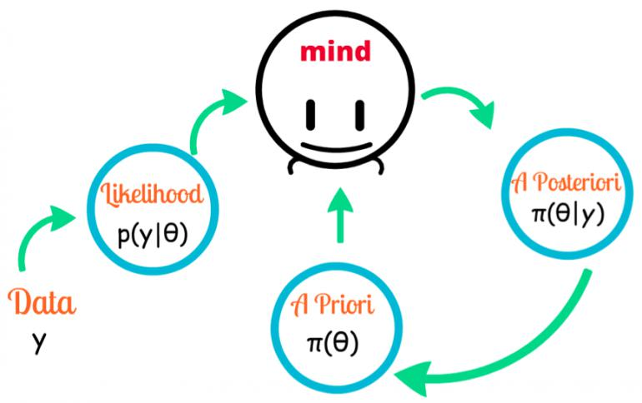

- Patient Details

The first part of the form is Patient Details. This part of the form will be automatically
filled up from the database. It consists of basic details like patient id, contact no, age
etc. The contact number obtained here will be the destination to which the SMS will
be sent.

- Prescription

The second part of the form is Prescription. This is the part of the form that will be
filled by the doctor himself. He will select all the medicines or salts that he wants to
prescribe. After this he can write some notes for the patients either on computer or
manually afterwards. Once he presses the SUBMIT button the medicines and salt
will form a list and will be transferred to patients mobile through SMS. He can also print
the prescription form if he wants to using the print buton.

Description of Our APP

- Vectorize the Dataset

To be able to apply the model on the dataset to generate a predictive model, the dataset needs to be converted from textual nature to a vector of numbers. The dataset thus vectorized can be fed into mathematical models to predict the nature of the mail. This vectorization needs to be implemented for both training and testing data
4

- Apply the Statistical Models

We use python package sklearn to apply the variety of statistical models on the dataset. The model which proves to give the highest precision can be used in the final ensemble of models.

Neural Network Based Approaches

Neural networks are powerful computational data models able to capture and represent complex high dimensional mappings. Lately neural network based architectures have been used in almost all classification tasks to generate state of the art results.

Goals

- Develop a fully connected neural network with appropriate non-linearities to model email text for classification.

- Use deep learning models which include RNN and CNN for end-to-end classification.

Specifications
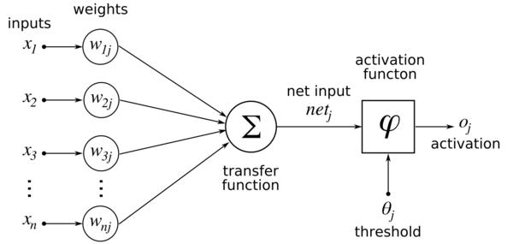

Mathematical modeling

Neural networks use matrix multiplications to transform data into linearly separable manifolds potentially in higher dimensions. This transformation combined with appropriate non-linear activations give neural networks unmatched learning capacity.
5

Advanced optimization techniques like Adagrad, RMSprop and Adam can be used to optimize learnable parameters in ways which are computationally inexpensive with minimal hardware dependency.

Milestones

- Develop a dense neural network for classification of email text with following salient points:

  - Pretrained GloVe embeddings can be used for word representation to incorporate a sense of meaning in word inputs.

  - Advanced regularization techniques which include Dropout and Batch Normalization can be used for handling overfitting of data which also allow us to use higher learning rates for faster convergence.

- Explore deep learning architectures which include

  - CNN ( convolutional neural network ) for capturing local variation and distribution of words in emails for better feature modeling.

  - RNN ( recurrent neural network ) for deep temporal mapping of words capturing sequential patterns in text which has been used in state-of-the-art language models.

Enriching FastText with Fine Hyperparameter Tuning

Goals

FastText is a fast-learning, fast-running text categorization method developed at FAIR by Mikolov et al. The method was developed mainly for sentiment classification. Here, we aim to use it for Spam Classification by using “Bag of Tricks” and well-designed input representations by carefully fine tuning the hyperparameters. We hope that these tricks will allow us to match with deep character-level ConvNets while maintaining a simple and faster architecture.

Brief History

Xiang Zhang, a PhD student from NYU set out to collect large datasets for experiments in topic classification and sentiment analysis. His idea was to collect enough data to train large neural networks. He tried many methods and found that for several datasets, large character-level convolutional nets are working quite well. He eventually open sourced his code now called Crepe.
6

More recently, Berrault et al. from FAIR-Paris used Zhang’s data and improved the results by using very deep character-level ConvNets, getting inspiration from recent work in image classification (e.g., Kaiming He’s ResNet architecture).

Specifications

FastText is a simple linear model with rank constraint. The first weight matrix A is a lookup table over the words. The word representations are then averaged into a text representation, which is in turn fed to a linear classifier. The text representation is a hidden variable which can potentially be reused. This architecture is similar to the CBOW model of Mikolov et al. (2013), where the middle word is replaced by a label. We use the softmax function f to compute the probability distribution over the predefined classes. For a set of N documents, this leads to minimizing the negative log likelihood over the classes.

Hierarchical Softmax

When the number of classes is large, computing the linear classifier is computationally expensive. More precisely, the computational complexity is O(kh) where k is the number of classes and h the dimension of the text representation. In order to improve our running time, we use a hierarchical softmax (Goodman, 2001) based on the Huﬀman coding tree (Mikolov et al., 2013). During training, the computational complexity drops to O(h log (k)).
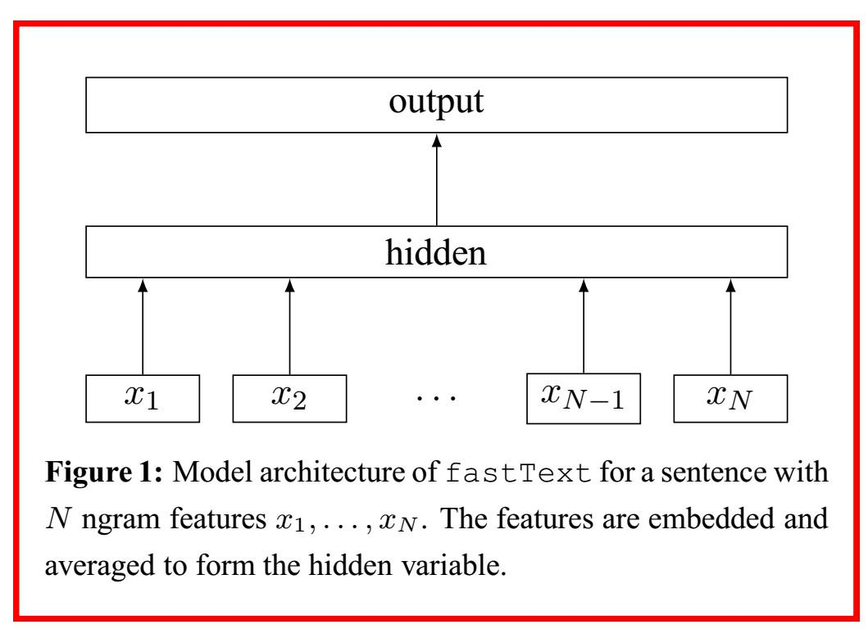
7

N-gram Features

Bag of words is invariant to word order but taking explicitly this order into account is often computationally very expensive. Instead, we will use a bag of n-grams as additional features to capture some partial information about the local word order. This is very eﬃcient in practice while achieving comparable results to methods that explicitly use the order (Wang and Manning, 2012).

Milestones

We aim to build a shallow neural network with the specifications provided above and fine tune the network by cross-validating over following hyper-parameters: learning rate, update rule, dimension of word vectors (internal representation), size of context window, number of epochs, number of negatives sampled, maximum length of word gram and loss function.

We will train our architecture on specified dataset using the conventional training and validation breakdown. Since all previous implementations of FastText are based on sentiment analysis (to the best of our knowledge), using it for our specific spam classification task may yield unexpected results.

eXtreme Gradient Boosting (XGBoost)

Goals

- An ideal model is one which is good at both generalization and prediction accuracy. This brings us to Boosting Algorithms.

- XGBoost (Extreme Gradient Boosting) is an optimized distributed gradient boosting library. Yes, it uses gradient boosting (GBM) framework at core. Yet, does better than GBM framework alone. XGBoost was created by Tianqi Chen, PhD Student, University of Washington. It is used for supervised ML problems.

- Parallel Computing: It is enabled with parallel processing (using OpenMP); i.e., when you run xgboost, by default, it would use all the cores of your laptop/machine.

Specification

- Regularization: This is the biggest advantage of xgboost. Regularization is a technique used to avoid overfitting in linear and tree-based models.
8

- Enabled Cross Validation: XGBoost is enabled with internal cross validation function.

- Missing Values: XGBoost is designed to handle missing values internally.The missing values are treated in such a manner that if there exists any trend in missing values, it is captured by the model.

4. | Flexibility: In addition to regression, classification, and | ranking | problems, |  | it
 | supports user-defined objective functions also. An objective function is |  |  | used | to
 | measure the performance of the model given a certain set of parameters.
 | Furthermore, it supports user defined evaluation metrics as well.
5. | Availability: Currently, it is available for programming | languages | such | as | R,
 | Python, Java, Julia, and Scala.

Mathematical Formulation
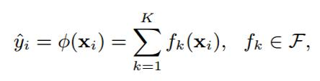

where K is the number of functions and F is the space of functions containing the partition

of the region and the score in each of them. Formally, we assume F to be a set of regression

trees. Because our model introduces functions as parameters, it allows us to find functions fk ∈ F that fit the data well when we train the model, thus finds corresponding regions automatically.

To learn the set of functions used in the model, we define the following regularized objective

function.
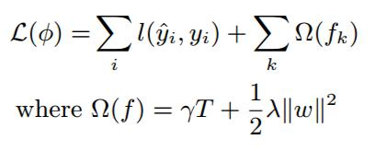

where I is a diﬀerentiable convex loss function that measures the diﬀerence between the prediction yi and the target yi . The second term Ω measures the complexity of the model (i.e., the feature functions) to avoid overfitting. One important fact about Eq. (2) is that
9

the objective is regularized, which means we are penalizing complicated models. With the objective function, a model employing simple and predictive functions will be selected as the best model.
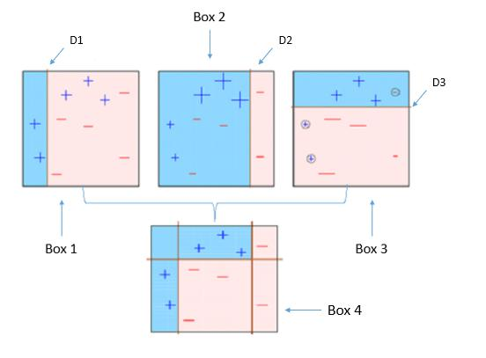

- Boxes 1,2, and 3 are weak classifiers. These classifiers will now be used to create a strong classifier Box 4.

- Box 4: It is a weighted combination of the weak classifiers. As you can see, it does good job at classifying all the points correctly.

How we used it

- We used the scikit-learn library with XGBoost models.

- The XGBoost model for classification is called XGBClassifier. We can create and and fit it to our training dataset.

- Models are fit using the scikit-learn API and the model.fit() function.

- We can make predictions using the fit model on the test dataset.

- To make predictions we used the scikit-learn function model.predict().

- By default, the predictions made by XGBoost are probabilities. Because spam classification is a binary classification problem, each prediction is the probability of the input pattern belonging to the first class. We can easily convert them to binary class values by rounding them to 0 or 1.
10

- Now that we have used the fit model to make predictions on new data, we can evaluate the performance of the predictions by comparing them to the expected values. For this we will use the built in accuracy_score() function in scikit-learn.

